LAB 7

Exercise 1 — Basic: Division with Exception Handling
File: DivisionDemo.java
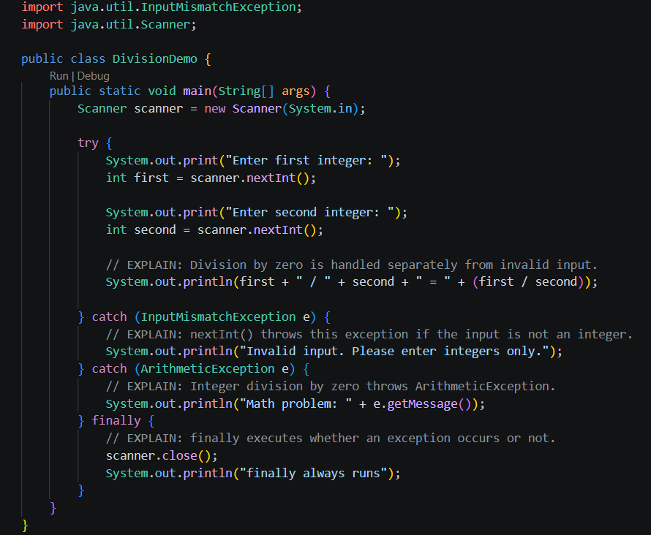
Output 1: divison by zero
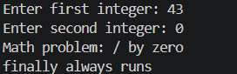
Output 2: non numeric input
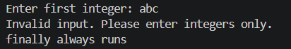

Exercise 2 — Basic: Array Index Exception
File: ArrayExceptionDemo.java
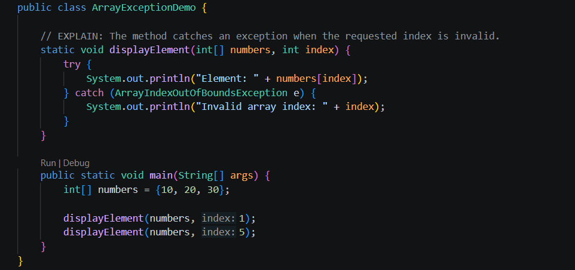
Output:
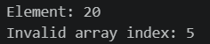

Exercise 3 — Intermediate: Checked InvalidAgeException
File 1: InvalidAgeException.java
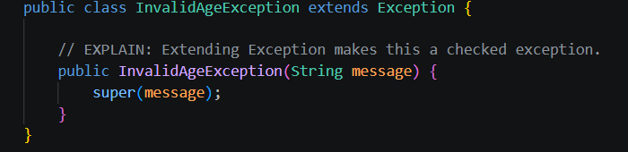

File 2: AgeValidationDemo.java
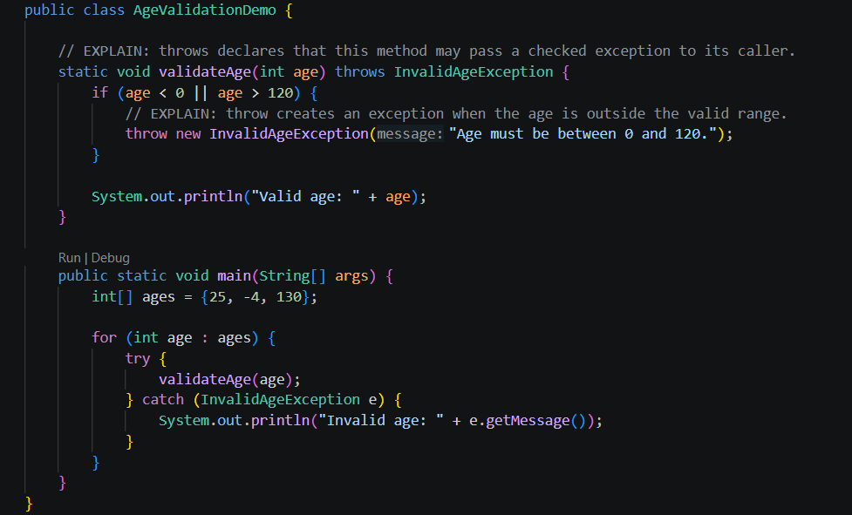

Output
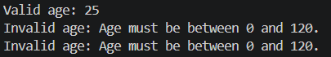

Exercise 4 — Bank account withdrawal
File 1: InsufficientFundsException.java
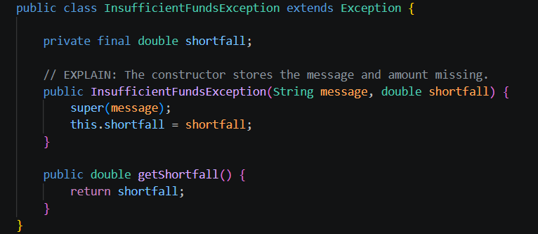
File 2: BankAccount.java
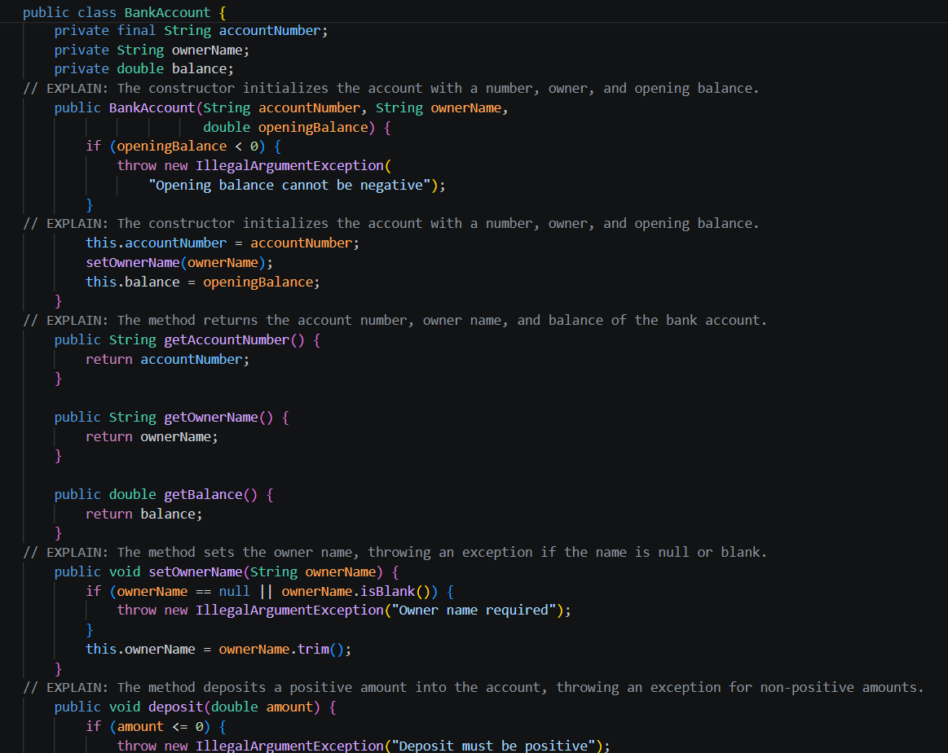
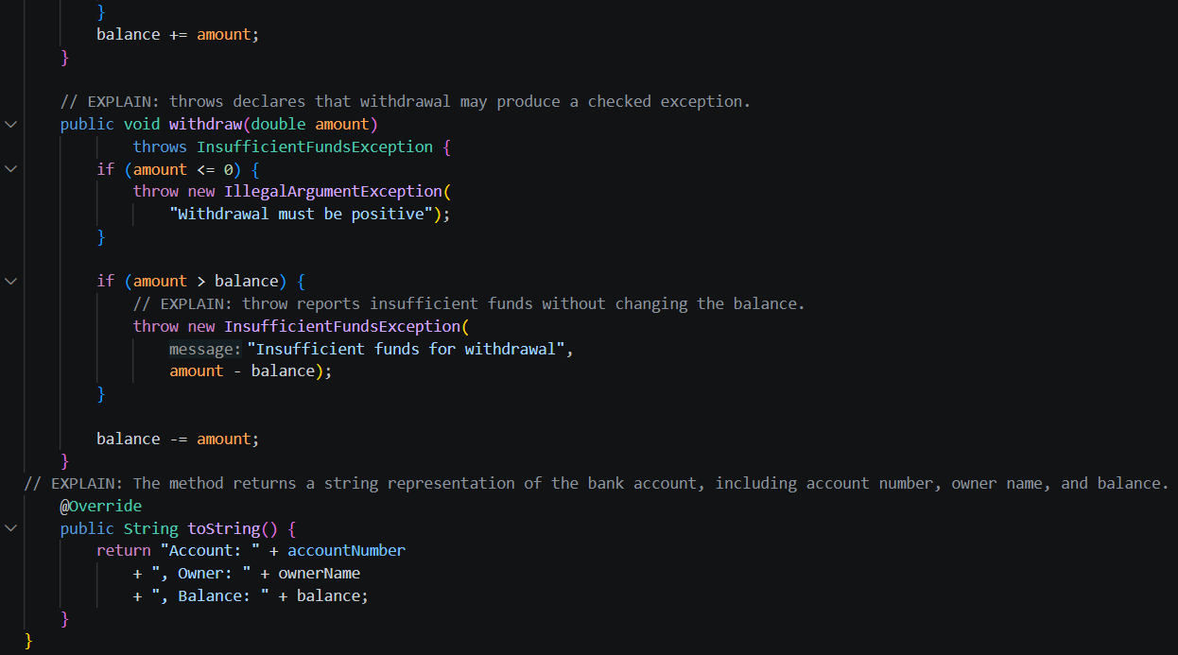

File 3: BankDemo.java
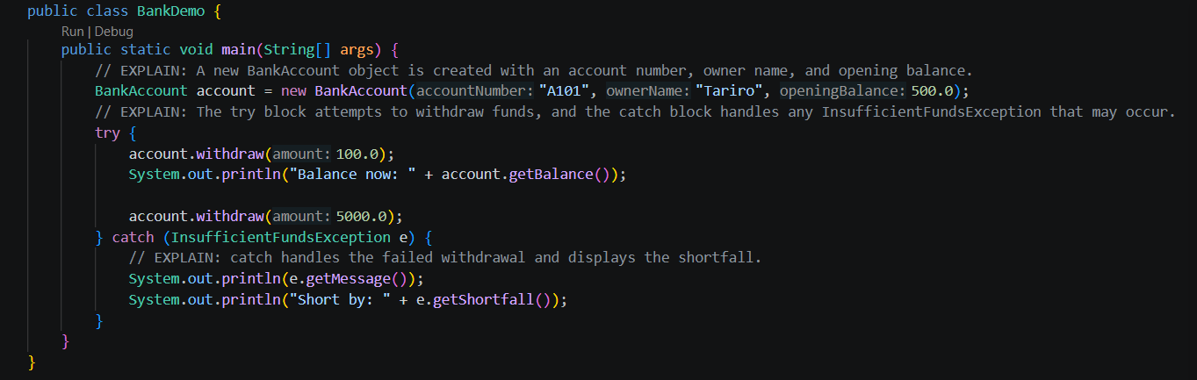

Trade-off
Throwing a checked exception makes the failure explicit, but callers must handle or declare it. Returning false is simpler, but callers may overlook the failure.

Exercise 5
File: FinallyDemo.java

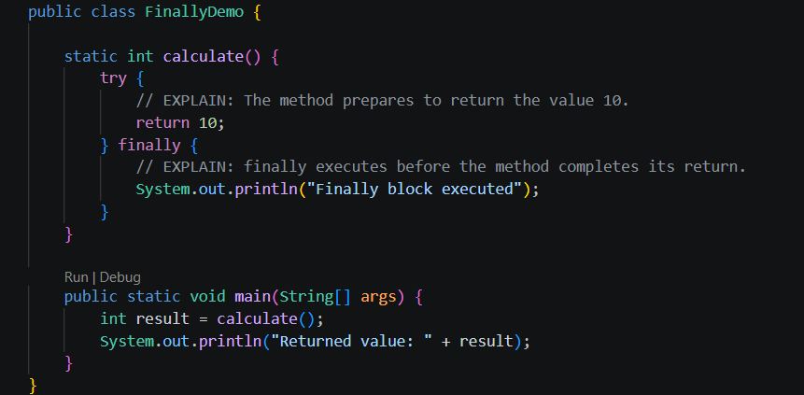

Output
